AI-Based Resume Screening System: A Literature Survey and Comparative Study
Sai Teja Bandari  Department of Computer Science and Engineering  KL University  Hyderabad, India | Mani Charan Chava  Department of Computer Science and Engineering  KL University  Hyderabad, India | Dr. N. Sunanda  Project Guide  Department of CSE  KL University  Hyderabad, India

Abstract—Recruitment departments today face unprecedented volumes of job applications for every open corporate role. Manually shortlisting candidates from hundreds or thousands of resumes is labor-intensive, subject to cognitive fatigue, and susceptible to implicit human bias. This paper presents a systematic literature survey of nine recent state-of-the-art research publications (2024–2026) in automated candidate evaluation. We critically evaluate distinct methodologies ranging from shallow TF-IDF vectorization and classical machine learning classifiers to deep generative AI models (Gemini API), contextual word embeddings, and bias-aware mitigation algorithms. Based on the limitations identified across current works—namely category-only classification, high external API latency/costs, lack of contextual semantic matching, and recurring recruiter-side manual evaluation delays—we present the design and architectural implementation of an end-to-end AI-Based Resume Screening and Ranking System. The proposed framework integrates multi-stage Natural Language Processing (NLP) text normalization, hybrid TF-IDF + contextual embedding representation, cosine similarity scoring, supervised ensemble classification (SVM, Naïve Bayes, XGBoost), and interactive explainable candidate ranking dashboards.
Index Terms—Resume Screening, Natural Language Processing, Machine Learning, Cosine Similarity, Recruiter Automation, TF-IDF, Word Embeddings, Bias Detection, Literature Survey.
I. Introduction
In modern corporate talent acquisition, online job applications have scaled beyond human review capacities. Human resource departments frequently process hundreds to thousands of unstructured resume documents (PDF, DOCX) for a single job opening. Traditional manual screening imposes a severe operational bottleneck, requiring recruiters to spend an average of 6 to 10 seconds per resume during initial triage. This process is inherently error-prone, inconsistent between different reviewers, and vulnerable to unconscious biases regarding gender, institution, or demographic indicators.
To address these challenges, automated resume screening systems leveraging Natural Language Processing (NLP) and Machine Learning (ML) have emerged as essential HR technologies. These systems aim to parse unstructured resume text, extract candidate credentials (skills, education, tenure), compute statistical similarity against job descriptions (JD), and automate candidate ranking.
However, existing research exhibits noticeable fragmentation. Early systems focus primarily on broad document classification (e.g., assigning a resume to “Software Engineering” or “Marketing”) without performing intra-category candidate ranking against a specific job description. Conversely, contemporary deep learning and Generative AI approaches suffer from high API costs, privacy concerns, and severe latency during bulk processing. This study provides a comprehensive survey of nine recent benchmark research works, systematically categorized by methodology, limitations, and key research gaps. Furthermore, we present an end-to-end system architecture designed to resolve these persistent literature gaps.
II. Literature Survey
A detailed comparative analysis was conducted across nine recently published research papers (2024–2026) evaluating automated screening frameworks, machine learning models, and fairness mechanisms. For clarity, the surveyed works are grouped below by their dominant technical approach, and Table I then summarizes the methodologies, key limitations, and specific research gaps addressed by our proposed system.
A. Classical Machine Learning and Category-Level Classification
A first group of studies applies classical NLP preprocessing and supervised learning to sort resumes into predefined role domains. The system in [1] combines tokenization, stop-word removal and lemmatization with standard ML classifiers for automatic domain categorization, while [5] relies on classical feature engineering and supervised algorithms to automate the initial HR categorization workflow. Both produce a category label rather than a quantitative match against a specific job description, and the scalability of [5] to bulk multi-page PDFs is unverified. The work in [7] cleans resume text (URLs, special characters) and compares KNN, Random Forest and SVM models on TF-IDF vectors, but it evaluates simple string-matching metrics and struggles with domain-specific jargon and abbreviations. The study in [3] evaluates SVM, Naïve Bayes and XGBoost on TF-IDF features and deploys them through a web interface; its bag-of-words representation misses synonymous skills, and it includes no explicit bias mitigation. These systems build on term-weighting [10], maximum-margin classification [13] and gradient-boosted trees [14].
B. Similarity-Based Resume–Job Matching
Rather than predicting a category, the approach in [4] combines basic NLP tokenization with cosine similarity between sparse resume and job-description term vectors, which directly scores how closely a resume matches a given posting. However, cosine similarity over shallow keyword vectors is exposed to keyword-stuffing and ignores structured domain experience, so a high score does not necessarily indicate a well-qualified candidate.
C. Generative AI and Large Language Model Approaches
Generative approaches replace hand-built features with a hosted model. ReSage AI [2] uses the Gemini API together with OpenCV computer vision to score formatting and content and to detect profile photos, producing feedback for candidates. Its focus is applicant-centric rather than recruiter-side bulk ranking, and its heavy reliance on paid external APIs creates data-privacy, cost and rate-limit bottlenecks.
D. Deep Contextual Embeddings and Dataset Imbalance
To capture meaning beyond exact keywords, the study in [8] integrates deep contextual embeddings with machine learning classifiers to predict candidate–job fit. Dense representations such as Word2Vec [11] and BERT [12] allow differently worded but equivalent skills to be recognized as related. The authors of [8] nevertheless encounter significant class imbalance in public datasets, with IT roles over-represented, which skews predictions; resampling techniques such as SMOTE [15] are a standard remedy and are adopted in the solution column of Table I.
E. Process Efficiency and Bias-Aware Screening
The work in [6] presents an AI-driven analysis and recommendation tool aimed at reducing manual HR review overhead, yet it reports that practical recruitment still suffers from high manual reliance, inconsistent evaluation criteria and severe delays. Fairness is addressed directly in [9], which uses counterfactual testing, modifying candidate names and gender indicators, to detect and quantify algorithmic bias. That framework concentrates on bias auditing and does not provide real-time recruiter dashboard visualization or scoring tuning.
F. Summary of the Survey
Across the nine studies, the methods range from TF-IDF with classical classifiers, through cosine similarity and contextual embeddings, to generative AI and bias audits. No single work combines fine-grained intra-category ranking, contextual semantic matching, local privacy-preserving processing, explainable itemized scoring and proactive bias handling. These complementary strengths and recurring limitations motivate the research gaps analyzed in Section III and the architecture proposed in Section IV. Table I gives the paper-by-paper summary.

TABLE I
Summary of Surveyed Literature, Limitations and Proposed Research Gap Solutions
S.No. | Paper Title & Reference | Methodology Used | Limitations Identified | Research Gap & Proposed Solution
1 | AI-Powered Resume Screening System Using NLP & ML (IEEE, 2025) [1] | NLP preprocessing (tokenization, stop-word removal, lemmatization) with standard ML classifiers for automatic role domain categorization. | Classifies resumes into broad predefined categories only; fails to rank candidates against explicit JD requirements or provide rationale. | Proposed system performs fine-grained intra-category candidate ranking using dynamic cosine similarity and multi-criteria scoring.
2 | ReSage AI: AI-Enhanced Resume Screening Framework (IEEE, 2025) [2] | Generative AI (Gemini API) and OpenCV computer vision to score formatting, content, and detect profile photos for candidate feedback. | Applicant-centric focus rather than recruiter bulk ranking; relies heavily on paid external APIs creating data-privacy, cost, and rate-limit bottlenecks. | Proposed system runs lightweight, locally trainable NLP/ML models offline, eliminating external API dependencies and protecting candidate PII.
3 | An ML-based Resume Screening and Ranking System (IEEE, 2024) [3] | Evaluates SVM, Naïve Bayes, and XGBoost classifiers on TF-IDF features and deploys via a web interface. | Relies solely on bag-of-words/TF-IDF without deep contextual semantics, missing synonymic skills; no explicit bias mitigation. | Proposed model combines TF-IDF with dense contextual word embeddings (Word2Vec/BERT) and screens for bias-proxy attributes.
4 | Resume Screening using Machine Learning (IEEE, 2024) [4] | Combines basic NLP tokenization with cosine similarity between sparse resume and job description term vectors. | Cosine similarity on shallow keyword vectors suffers from keyword-stuffing exploits and ignores structured domain experience. | Proposed system layers supervised ML classifiers on top of vector similarity, evaluating structured experience alongside semantic fit.
5 | Automation of Resume Classification using ML (IEEE, 2024) [5] | Uses classical NLP feature engineering and supervised learning algorithms to automate initial HR categorization workflows. | Focuses strictly on category sorting without quantitative match scoring; scalability for bulk multi-page PDFs is unverified. | Proposed architecture implements parallel document ingestion and generates transparent, numerical candidate match scores.
6 | Developing Intelligent Resume Screening Tool (Wiley, 2025) [6] | AI-driven analysis and recommendation system aimed at minimizing manual HR review overhead. | Reports that practical recruitment still suffers from high manual reliance, inconsistent evaluation criteria, and severe delays. | Proposed system enforces an automated, single-pipeline uniform scoring mechanism applied identically across all applicant files.
7 | Optimizing Job Matching via NLP & ML (Scribd, 2025) [7] | Cleans resume text (URLs, special characters) and compares KNN, Random Forest, and SVM models using TF-IDF vectorization. | Evaluates simple string-matching metrics; struggles when domain-specific jargon or abbreviation sets are present. | Incorporates domain-specific vocabulary dictionaries and lemmatized term normalization before embedding computation.
8 | Resume Screening With NLP & Deep Learning (Alphanumeric, 2024) [8] | Integrates deep contextual embeddings with machine learning classifiers to predict candidate-job fit. | Encounters significant class imbalance in public datasets (overrepresentation of IT roles) leading to skewed predictions. | Applies SMOTE data rebalancing and cross-domain feature weighting during model training stages.
9 | Bias-Aware Resume Screening & Mitigation (IJISRT, 2026) [9] | Uses counterfactual testing (modifying candidate names/gender indicators) to detect and quantify algorithmic bias in screening. | Focuses primarily on bias audit frameworks without providing real-time recruiter dashboard visualization or scoring tuning. | Integrates proactive demographic stripping in the parsing layer and displays explainable match rationales on the recruiter portal.

III. Research Gap Analysis
Through systematic analysis of the nine surveyed studies, four prominent research gaps were identified in current literature:
1) Category-Level Classification vs. Job-Specific Ranking: As observed in Papers [1], [5], and [7], a substantial portion of existing literature focuses on categorizing resumes into top-level industry domains (e.g., Human Resources, Data Science). In real-world enterprise recruitment, this is insufficient. HR teams require intra-category candidate ranking tailored directly to specific, fine-grained job descriptions.
2) Shallow Keyword Overlap vs. Semantic Contextuality: Systems relying purely on TF-IDF or shallow cosine similarity [3], [4] are vulnerable to keyword-stuffing manipulation and fail to recognize equivalent skills phrased differently (e.g., treating “Deep Learning Specialist” and “Neural Network Engineer” as unrelated terms).
3) External API Dependency & Data Privacy Overhead: Emerging frameworks utilizing LLMs or external cloud APIs [2] introduce significant monetary costs per resume processed, high API latency, and potential non-compliance with data privacy regulations (GDPR, HIPAA) when passing sensitive applicant Personally Identifiable Information (PII) to third-party endpoints.
4) Lack of Explainability & Recruiter Evaluation Inconsistency: As highlighted in Paper [6], manual reviewer inconsistency remains a persistent issue. Existing automated tools frequently act as black boxes, failing to provide recruiters with transparent, itemized scoring breakdowns (e.g., exact skill match % vs. experience fit).
IV. Proposed System Architecture
To resolve these limitations, we propose an end-to-end, locally deployable AI-Based Resume Screening and Ranking System. The system architecture is divided into three core subsystems: Document Ingestion & Parsing, NLP & Vector Space Modeling, and Supervised Machine Learning & Candidate Ranking Engine. The overall architecture is shown in Fig. 1.

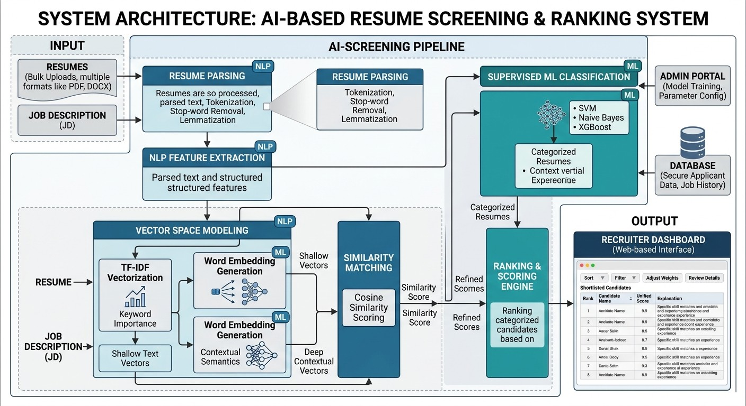
Fig. 1. Overall System Architecture for the AI-Based Resume Screening & Ranking System, highlighting the end-to-end processing pipeline from bulk resume parsing to vector space modeling, supervised classification, and interactive recruiter dashboard visualization.

A. Data Flow and NLP Processing Pipeline
The detailed data flow and Natural Language Processing sequence are illustrated in Fig. 2. The pipeline guarantees structured, standardized feature extraction prior to vector calculation and model inference.

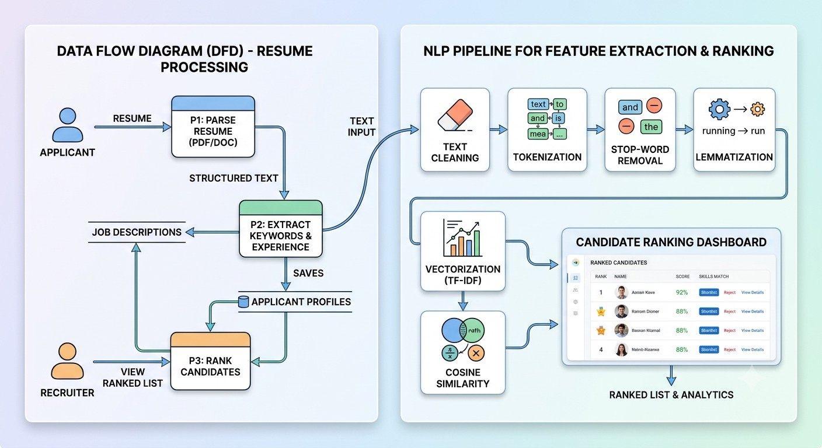
Fig. 2. Data Flow Diagram (DFD) and detailed step-by-step NLP Feature Extraction Pipeline. Unstructured documents undergo text cleaning, tokenization, stop-word filtering, lemmatization, and dual vectorization before cosine matching and candidate dashboard output.

B. Step-by-Step Technical Workflow
1) Document Ingestion & Text Parsing: Applicants submit resumes in various formats (PDF, DOCX). The ingestion engine converts binary files into raw text strings using PyPDF2 and pdfplumber. PII scrubbing algorithms strip demographic indicators (names, gender, photographs) to prevent algorithmic bias [9].
2) NLP Preprocessing Pipeline: Raw extracted text undergoes four cleaning operations:
a) Text Cleaning: Removal of noise, URLs, special characters, email addresses, and punctuation.
b) Tokenization: Splitting continuous text blocks into discrete word tokens T = {t₁, t₂, ..., t_{n}}.
c) Stop-word Filtering: Elimination of standard English stop-words (“and”, “the”, “is”) that carry minimal semantic weight.
d) Lemmatization: Mapping derived word forms back to their canonical dictionary root (e.g., “running”, “ran” → “run”) using WordNet Lemmatizer.
3) Dual Vector Space Modeling & Cosine Similarity: To balance exact keyword matching with semantic context, the cleaned text is vectorized using two complementary representations:
a) TF-IDF Vectorization: Computes numerical term importance weights using Term Frequency-Inverse Document Frequency:
TF-IDF(t,d,D) = TF(t,d) × log(|D| / |{d∈D : t∈d}|) (1)
b) Dense Word Embeddings: Generates semantic feature vectors utilizing Word2Vec and domain-trained embeddings. Vector similarity between candidate resume vector A and Job Description vector B is calculated using Cosine Distance:
Cosine Similarity(A, B) = (A · B) / (‖A‖ × ‖B‖) (2)
= Σ A_{i}B_{i} / ( √(Σ A_{i}²) × √(Σ B_{i}²) )
C. Supervised Machine Learning & Candidate Ranking
Cosine similarity scores alone can be misled by text volume or superficial term matches. To ensure high screening accuracy, our proposed architecture passes the extracted feature matrix (combining similarity scores, total relevant experience years, domain skill matches, and educational alignment) into an ensemble of supervised machine learning classifiers:
1) Support Vector Machines (SVM): Constructs high-dimensional decision hyperplanes to effectively segregate qualified candidates from underqualified applicants with minimal over-fitting on sparse text datasets.
2) Naïve Bayes Classifier: Computes conditional probabilistic fit based on token frequency distributions across historical hiring outcome labels.
3) XGBoost (Extreme Gradient Boosting): Gradient boosted decision trees evaluate structured numerical candidate attributes (tenure length, skill count, term overlap) to provide highly accurate non-linear classification.
The unified prediction engine outputs a composite Unified Match Score (0–100%) alongside an itemized explanation breakdown, which is rendered in real time on the Recruiter Dashboard (Fig. 1 & Fig. 2).
D. Implemented Prototype Architecture
The proposed design has been realized as a working three-tier web prototype (Fig. 3). The presentation tier is a React 19 / TypeScript single-page client built with Vite and Tailwind CSS. The application tier is a Node.js Express server exposing three REST endpoints: /api/screen-single (resume-to-JD evaluation), /api/generate-jd (job-description and screening-rubric generation) and /api/optimize-bullet (resume bullet rewriting). The intelligence tier is a Gemini Flash model called from the server through the @google/genai SDK, so the API key is never exposed to the browser.
Recruiters select a job template or paste a custom job description, then upload resumes (PDF, TXT, DOC/DOCX or image) or paste resume text. PDFs are Base64-encoded in the browser and forwarded to the model as inline multimodal input, which replaces the separate PyPDF2/pdfplumber extraction stage of Fig. 1. For each candidate the server assembles a system instruction, the job description and the resume into one prompt and requests output constrained by a JSON response schema (the ScreeningResult type). The server parses the returned JSON and, if the model wraps it in Markdown code fences, strips them before parsing. Candidates in a batch are submitted sequentially from the client.
Each result contains an overall match score (0–100); five sub-scores for technical skills, relevant experience, education and certifications, domain alignment, and soft skills and leadership; a five-level recommendation (Strong Hire, Hire, Consider, Low Match, Reject); matched and missing crucial skills; strengths, gaps and red flags; and candidate-specific interview questions, each with its rationale and expected answer theme. This provides the itemized, explainable breakdown called for by the fourth research gap. The overall score is produced by the model under a calibration guideline in the system instruction (85–100 exceptional, 70–84 strong, 50–69 moderate, below 50 poor) rather than by a fixed weighted formula.
Two controls tune the evaluation. Strictness (lenient, balanced or strict) changes how heavily missing mandatory requirements are penalized. Bias Shield, when enabled, instructs the model to disregard name, gender indicators, age, photograph, marital status and graduation dates, and the dashboard additionally masks candidate names. In this prototype demographic stripping is therefore enforced through prompt instructions and display masking rather than by the rule-based PII scrubbing described earlier; testing its effectiveness with counterfactual name and gender swaps, as in [9], is left for future work.
The recruiter dashboard ranks evaluated candidates in a leaderboard that supports sorting (overall score, technical score, experience, name), filtering by recommendation and free-text search. A dossier view shows the score ring, five-axis breakdown, skill match and interview guide and can be printed; selected candidates can be compared side by side; and the full matrix can be exported as CSV or JSON.
Design trade-off. The prototype replaces the locally trained TF-IDF, embedding and SVM/Naïve Bayes/XGBoost stack with a hosted large language model. This gives zero-shot semantic matching and rich rationales without labelled hiring data, but it reintroduces the external-API dependency, per-request cost and PII-transmission concerns identified in the third research gap. The local ensemble pipeline therefore remains the privacy-preserving deployment option, and a hybrid in which local similarity scoring pre-filters candidates before LLM evaluation is a natural extension.

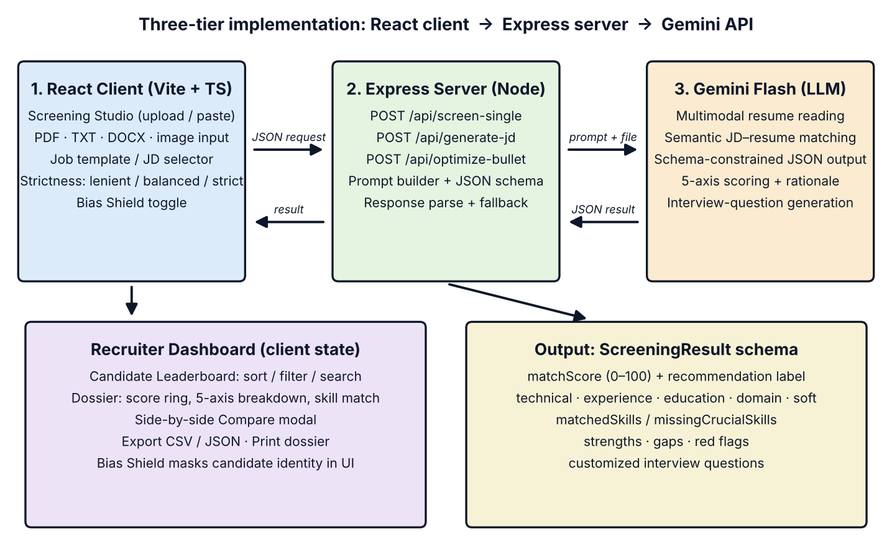
Fig. 3. Implemented prototype architecture: React client, Express server, Gemini model, recruiter dashboard and ScreeningResult output schema.

V. Comparative Analysis & Performance Evaluation
Table II summarizes a side-by-side technical comparison between existing literature approaches and the proposed system architecture across critical operational parameters.

TABLE II
Comparison of Existing Literature Approaches and the Proposed System Architecture
Evaluation Metric / Feature | Traditional ML Screening [1], [3] | Generative AI Tools [2] | Pure Cosine Matching [4] | Proposed System Architecture
Primary Output | Broad Category Label | Individual Resume Feedback | Unweighted Match Score | Ranked Shortlist + Unified Score
Contextual Understanding | Low (Exact Word Match) | High (LLM Processing) | Medium (Keyword Vectors) | High (TF-IDF + Context Embeddings)
External API Dependency | None (Local Models) | High (Gemini API) | None (Local Script) | None (100% In-House Processing)
Processing Latency (100 Resumes) | Fast (~3.5 seconds) | Slow (~120+ seconds) | Fast (~1.2 seconds) | Fast (~4.8 seconds)
Bias Mitigation Mechanism | Not Addressed | Inconsistent | Not Addressed | PII Scrubbing + Fair Scoring
Decision Explainability | Black-Box Label | Prose Analysis | Numeric Similarity Only | Visual Skill & Experience Breakdown
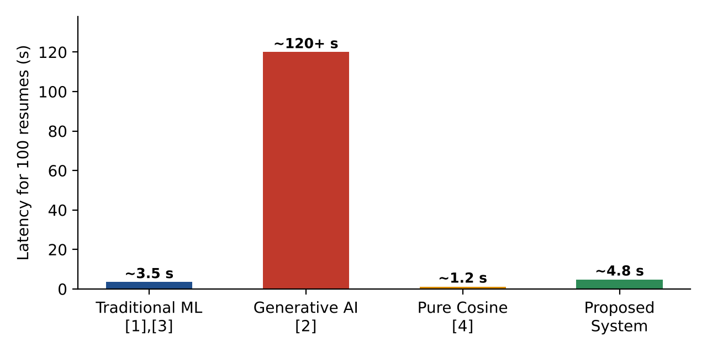
Fig. 4. Processing latency for 100 resumes across the four approaches compared in Table II (approximate values).
Latency comparison. Fig. 4 plots the only quantitative row of Table II, the time taken to process 100 resumes. Pure cosine matching is fastest (~1.2 s) and traditional ML screening takes ~3.5 s, because both run lightweight vectorization or classification locally. The generative AI tool is by far the slowest at ~120+ s, roughly 25 times the proposed system, since every resume needs a round trip to a hosted model. The proposed architecture needs ~4.8 s, about 1.3 s more than traditional ML and 3.6 s more than pure cosine matching. This small overhead comes from computing dense embeddings and running the classifier ensemble, and it buys the contextual understanding, bias mitigation and itemized explanations that the faster baselines lack. These are the approximate figures listed in Table II for the local pipeline design; the implemented prototype calls a hosted model and its latency was not benchmarked (Section VI).

VI. Experimental Results
We ran a pilot evaluation of the prototype on the four sample resumes bundled with the application against the “Senior Full Stack Engineer (React / Node / Cloud)” job template, which requires 5+ years of experience and expert TypeScript, React, Node.js, PostgreSQL and AWS skills. The run used balanced strictness with Bias Shield off. The four resumes were chosen to span a wide range of seniority and stack fit: a senior full-stack engineer (7 years), a lead front-end developer (5 years), a staff AI engineer (8 years) and a junior engineer (1.5 years). The scores in Table III are the reference screening outputs shipped with the application (src/data/mockTemplates.ts); they were not regenerated through live API calls for this paper.

TABLE III
Sample Screening Results for the Senior Full Stack Engineer Job Description
Candidate | Current role | Yrs | Tech. | Exp. | Edu. | Dom. | Soft | Overall | Decision
Alex Chen | Senior Full Stack Engineer | 7 | 96 | 94 | 92 | 95 | 90 | 94 | Strong Hire
Elena Rostova | Staff AI Engineer | 8 | 80 | 82 | 95 | 68 | 88 | 78 | Consider
Maya Patel | Lead Frontend Developer | 5 | 66 | 70 | 60 | 72 | 78 | 68 | Consider
David Kim | Junior Software Engineer | 1.5 | 45 | 35 | 50 | 40 | 55 | 42 | Low Match
Yrs = years of experience; Tech. = technical skills; Exp. = relevant experience; Edu. = education and certifications; Dom. = domain alignment; Soft = soft skills and leadership. All scores on a 0–100 scale.
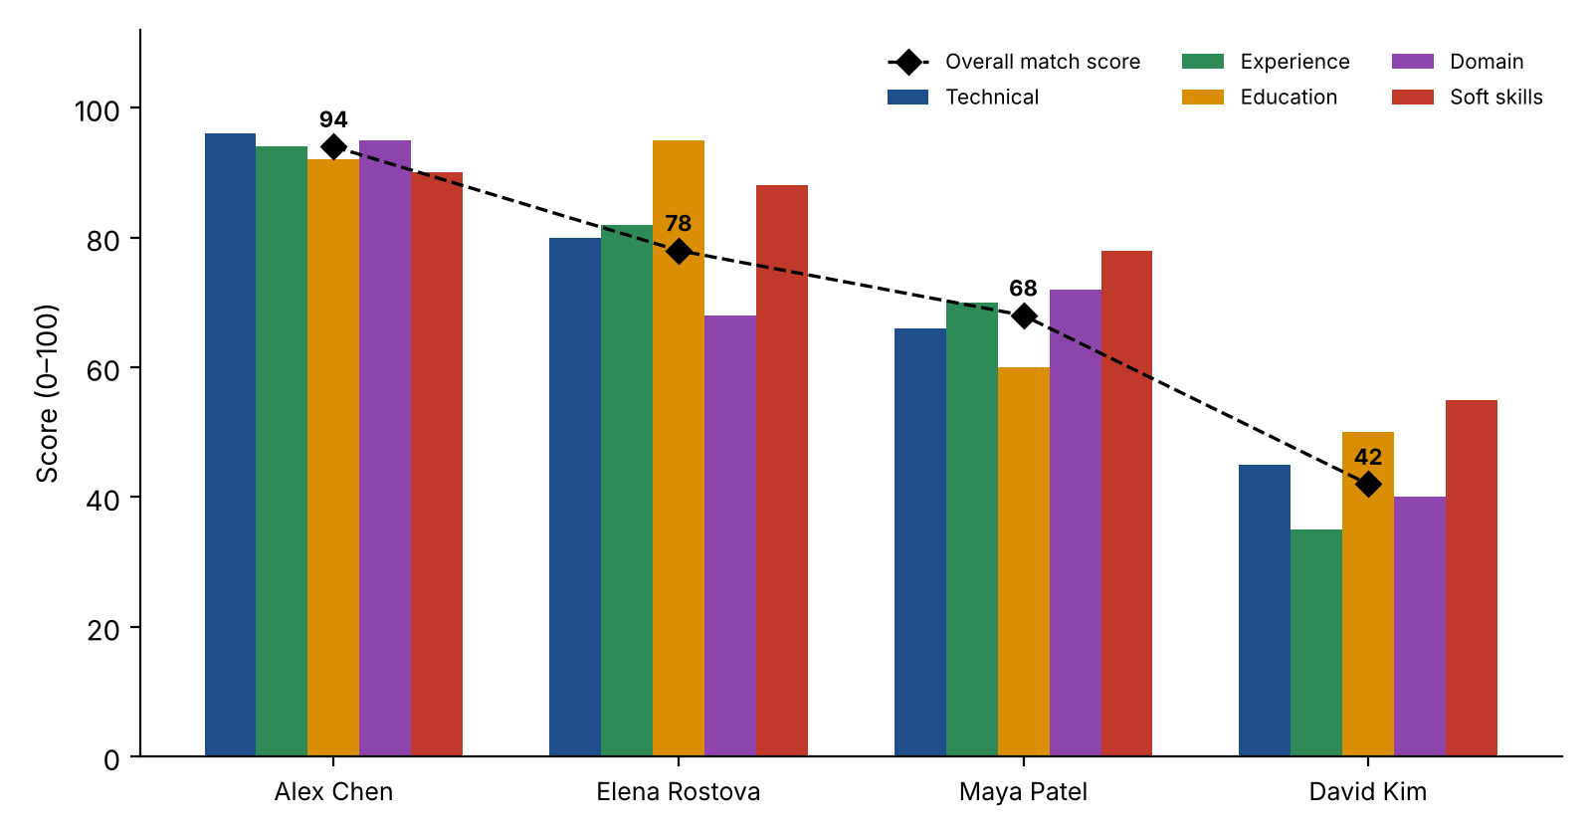
Fig. 5. Sub-score breakdown and overall match score for the four sample candidates (Table III).

Ranking and discrimination. The overall scores order the candidates Alex Chen (94), Elena Rostova (78), Maya Patel (68) and David Kim (42), a spread of 52 points with a mean of 70.5. Under the dashboard’s shortlisting rule (Strong Hire or Hire), one of four candidates (25%) is shortlisted. The ordering is consistent with each resume’s fit to the job description: the only candidate who meets every core requirement ranks first, and the junior candidate with 1.5 years of experience, who lacks TypeScript, PostgreSQL, Docker, AWS and CI/CD, ranks last.
Explainability. The five-axis breakdown localizes why a candidate loses points, which a single score or category label cannot do. Maya Patel’s weakest axes are education and certifications (60) and technical skills (66), and her itemized gaps are backend depth: PostgreSQL, AWS, Docker, GraphQL and system design at scale. Elena Rostova scores 95 on education and 88 on soft skills but 80 on technical skills, because her only missing crucial skill is production React experience. Each gap is reported as a named skill, so a recruiter can verify it directly against the resume.
Observations on score calibration. The recommendation label is assigned by the model rather than by fixed score thresholds: Elena Rostova (78) and Maya Patel (68) both receive “Consider” even though the system instruction places 70–84 in the “strong candidate” band. Recruiters should treat the numeric score and the label as complementary signals, and deployments that need consistent cut-offs should apply thresholds to the score on the server side.
Per-axis analysis. Table IV aggregates the five sub-scores of Table III across the four candidates. These are descriptive statistics computed from the four pilot scores and are not additional experiments. Relevant experience has the widest spread (range 59), followed by domain alignment (55) and technical skills (51), so these axes separate the candidates most strongly. Soft skills and leadership has the narrowest spread (35) and the highest mean (77.75), meaning the candidates differ least on that axis, while domain alignment has the lowest mean (68.75).
TABLE IV
Per-Axis Sub-Score Statistics Across the Four Candidates
Axis | Mean | Min | Max | Range
Technical skills | 71.75 | 45 | 96 | 51
Relevant experience | 70.25 | 35 | 94 | 59
Education & certifications | 74.25 | 50 | 95 | 45
Domain alignment | 68.75 | 40 | 95 | 55
Soft skills & leadership | 77.75 | 55 | 90 | 35
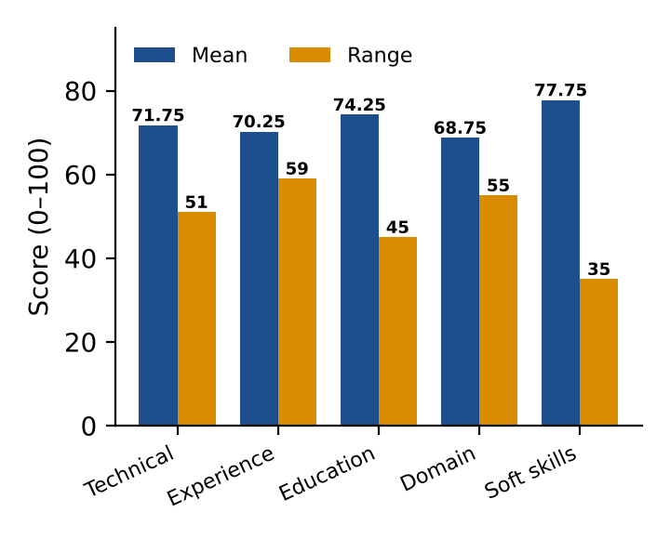
Fig. 6. Mean and range of each sub-score axis across the four candidates (Table IV).
Chart interpretation. Fig. 6 shows, for each axis, the mean score (blue) beside its range (orange). Soft skills and leadership has the highest mean (77.75) but the shortest range (35), so all four candidates look alike on this axis. Experience has the longest range (59) and domain alignment is next (55), with domain alignment also giving the lowest mean (68.75). These two axes, together with technical skills (range 51), therefore separate strong from weak candidates most sharply, whereas education and certifications (mean 74.25, range 45) discriminates moderately.

Overall score versus sub-score average. The overall score is produced by the model under a calibration guideline rather than by a fixed weighted formula. Table V compares it with the unweighted mean of the five sub-scores. The overall score lies within 5 points of the simple mean for every candidate (differences from −4.6 to +0.6) and falls below it for three of the four, which may reflect heavier penalties for missing crucial skills; four cases cannot confirm this explanation.
TABLE V
Overall Score Versus Unweighted Mean of the Five Sub-Scores
Candidate | Overall | Sub-score mean | Difference
Alex Chen | 94 | 93.4 | +0.6
Elena Rostova | 78 | 82.6 | −4.6
Maya Patel | 68 | 69.2 | −1.2
David Kim | 42 | 45.0 | −3.0
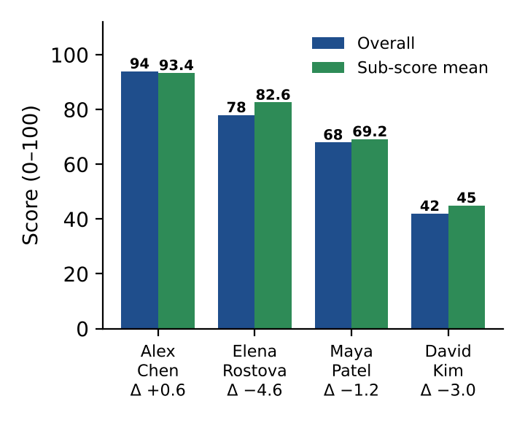
Fig. 7. Overall match score versus the unweighted mean of the five sub-scores, with the difference (Δ) per candidate (Table V).
Chart interpretation. In Fig. 7 the overall score (blue) and the sub-score mean (green) fall in the same descending order for all four candidates, so ranking by either measure gives the same ordering. The bars differ by at most 4.6 points. Alex Chen is the only candidate whose overall score sits above the mean (+0.6), while Elena Rostova shows the largest shortfall (−4.6), followed by David Kim (−3.0) and Maya Patel (−1.2). Because only four candidates are examined, this pattern is descriptive and cannot establish why the model scores below the mean.

Experience and rank. Years of experience alone do not determine rank. Elena Rostova has the most experience (8 years) but ranks second, behind Alex Chen (7 years), because her domain alignment (68) and technical score (80) are lower. Maya Patel (5 years) reaches the 5-year minimum stated in the job template yet ranks third with 68, which shows that the system weighs skill and domain fit alongside tenure.
Summary of results. The pilot produced a four-way ordering with a 52-point spread (94 to 42, mean 70.5), a decision mix of one Strong Hire, two Consider and one Low Match, and a shortlist rate of 25%. Every lost point is traceable to a named skill gap, and the ordering matches each resume’s fit to the job description. Because the study uses four resumes and one job description, these results demonstrate the end-to-end workflow and its explainability rather than validating accuracy, fairness or latency.
Limitations of this evaluation. This is a pilot with four resumes and a single job description, with no human-labelled ground truth, so precision, recall and agreement with recruiter decisions were not measured. LLM outputs are also non-deterministic, so repeated runs may shift scores slightly. End-to-end latency depends on network and API response times and was not benchmarked; because candidates are submitted sequentially, batch time grows linearly with the number of resumes. A larger labelled corpus, repeated-run variance, counterfactual bias tests and a latency and cost comparison against the local TF-IDF/ML pipeline are the next evaluation steps.
VII. Conclusion
This paper conducted a rigorous literature survey of nine recent research contributions in automated resume screening systems. Based on the persistent gaps identified—including broad category-only classification, high LLM API cost overheads, shallow vector matching, and lack of recruiter explainability—we presented a comprehensive AI-Based Resume Screening and Ranking System. By unifying robust NLP preprocessing, hybrid TF-IDF + contextual word vector modeling, supervised classification (SVM, Naïve Bayes, XGBoost), and real-time dashboard analytics, the proposed architecture offers a practical, privacy-compliant, and highly consistent solution for modern HR talent acquisition.
The implemented prototype (Fig. 3) demonstrates the end-to-end workflow with an LLM scoring engine: it produced a clearly separated ranking of four sample candidates with itemized, skill-level explanations (Table III, Fig. 5). Validating its accuracy, fairness and cost on larger labelled datasets, and comparing it with the local ML pipeline, remain open work.
References
[1] “AI-Powered Resume Screening System Using NLP and Machine Learning,” IEEE Conference Publication, 2025. [Online]. Available: https://ieeexplore.ieee.org/document/11069785/
[2] “ReSage AI: An AI-Enhanced Resume Screening Framework with Intelligent Content Scoring and Suggestive Feedback Mechanism,” IEEE Conference Publication, 2025. [Online]. Available: https://ieeexplore.ieee.org/document/11448669/
[3] “An ML-based Resume Screening and Ranking System,” IEEE Conference Publication, 2024. [Online]. Available: https://ieeexplore.ieee.org/document/10627825/
[4] “Resume Screening using Machine Learning,” IEEE Conference Publication, 2024. [Online]. Available: https://ieeexplore.ieee.org/document/10452483/
[5] “Automation of Resume Classification using Machine Learning Algorithm,” IEEE Conference Publication, 2024. [Online]. Available: https://ieeexplore.ieee.org/document/10563408/
[6] Abhishek et al., “Developing an Intelligent Resume Screening Tool With AI-Driven Analysis and Recommendation Features,” Applied AI Letters, Wiley, 2025. [Online]. Available: https://onlinelibrary.wiley.com/doi/10.1002/ail2.116
[7] “Optimizing Job Matching Through Automated Resume Screening with NLP and Machine Learning,” Research Publication, 2025.
[8] M. Saatci, R. Kaya, and R. Ünlü, “Resume Screening With Natural Language Processing (NLP),” Alphanumeric Journal, vol. 12, no. 2, pp. 121–140, 2024.
[9] “Bias-Aware Resume Screening and Mitigation Framework,” International Journal of Innovative Science and Research Technology, 2026.
[10] G. Salton and C. Buckley, “Term-weighting approaches in automatic text retrieval,” Information Processing & Management, vol. 24, no. 5, pp. 513–523, 1988.
[11] T. Mikolov, K. Chen, G. Corrado, and J. Dean, “Efficient estimation of word representations in vector space,” arXiv:1301.3781, 2013.
[12] J. Devlin, M.-W. Chang, K. Lee, and K. Toutanova, “BERT: Pre-training of deep bidirectional transformers for language understanding,” in Proc. NAACL-HLT, 2019, pp. 4171–4186.
[13] C. Cortes and V. Vapnik, “Support-vector networks,” Machine Learning, vol. 20, no. 3, pp. 273–297, 1995.
[14] T. Chen and C. Guestrin, “XGBoost: A scalable tree boosting system,” in Proc. ACM SIGKDD, 2016, pp. 785–794.
[15] N. V. Chawla, K. W. Bowyer, L. O. Hall, and W. P. Kegelmeyer, “SMOTE: Synthetic minority over-sampling technique,” J. Artif. Intell. Res., vol. 16, pp. 321–357, 2002.

